REDBERRY GLOBAL INSTALLATION GUIDE

Last Modification Date: 10/06/2009

Index

Guide Notes before Installation

Installing Redberry Global on a Standalone Computer
Installing Redberry Global on a Network

Redberry Global Application

Installing Redberry Global Application
Setting Up Redberry Global Application

Redberry Global Update Manager

Installing Redberry Global Update Manager
Setting Up Redberry Global Update Manager

Redberry Global Print Manager

Installing Redberry Global Print Manager
Setting up Redberry Global Print Manager

Redberry Global Email Manager

Installing Redberry Global Email Manager
Setting Up Redberry Global Email Manager

Redberry Global Client

Installing Redberry Global Client
Setting Up Redberry Global Client
Starting Redberry Global Client

Redberry Global Reports

Installing Redberry Global Reports

Guide Notes before Installation

Installing Redberry Global on a Standalone Computer

The Full Application Setup List is below. The first Product you should install is the Redberry Global Application.

Redberry Global Application Application Setup: global_application.exe
Redberry Global Update Manager Application Setup: global_update.exe
Redberry Global Print Manager Application Setup: global_spoolit.exe
Redberry Global Email Manager Application Setup: global_dial.exe
Redberry Global Client Application Setup: global_client.exe
Redberry Global Reports Application Setup: global_reports.exe

The other Installs can be Installed in any order, however you may want to Install the Redberry Global Client, because this allows access to the Application, which means that you take a tour before you continue with the rest of the installation.

Installing Redberry Global on a Network

PIER-TO-PIER NETWORKS
Redberry Global was designed to operate on the simplest of Networks and although it is possible for Redberry Global to run on a Pier-to-Pier Network without interfering with Workstation acting as the Server, it is not recommended, if the Workstation is rebooted without first ensuring all Users are out of Redberry Global then the Databases will almost certainly suffer some corruption.

The following Installation should be installed on the Computer you intend to use as the Server

Redberry Global Application Application Setup: global_application.exe
Redberry Global Update Manager Application Setup: global_update.exe
Redberry Global Print Manager Application Setup: global_spoolit.exe
Redberry Global Email Manager Application Setup: global_dial.exe

The first product you should install is the Redberry Global Application; the rest can be installed in any order.

In order to install on a Network Server you must be logged on with Administrator rights.

All the Installation offer a default Installation Location as C:\REDSOFT, however it is normal that may not wish to share the REDSOFT Folder from the C:\ Drive, or you reserved the C:\ Drive for the operating system. The Default Drive can be changed during the install to any other Drive and or Folder, however it is recommended that Redberry Global is installed in the REDSOFT Parent Folder under the location you may wish.

When you have completed the install of the Redberry Global Application, it is important that you share this folder out across the Network, with full access rights to Users that will use the Global Application.

The last two Application Setups are for installation on the each of the workstations that are going to access Redberry Global

Redberry Global Client Application Setup: global_client.exe
Redberry Global Reports Application Setup: global_reports.exe

Redberry Global Application

Installing Redberry Global Application

Run Application Setup: global_application.exe

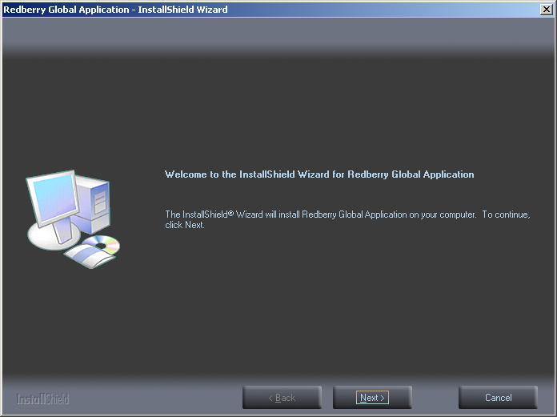 | Press the Button to continue with the installation
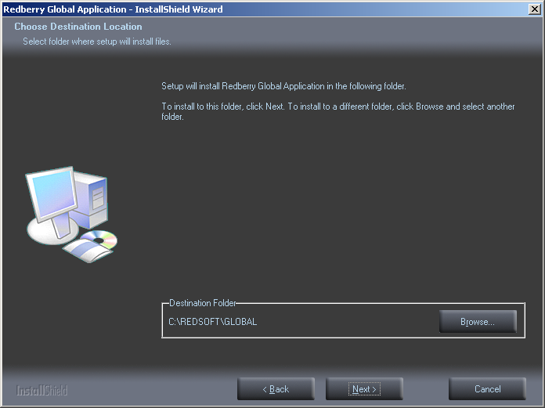 | Select Destination Folder for Application Installation  Default offered – C:\REDSOFT\GLOBAL  This Folder should be accepted when Redberry Global is being used on a standalone P.C. and not shared across the network.  If you are installing on a File Server you may wish to install the application on a Drive other than C:\ which you may wish not to share, if so see the next section below.  Press the Button to continue with the installation.
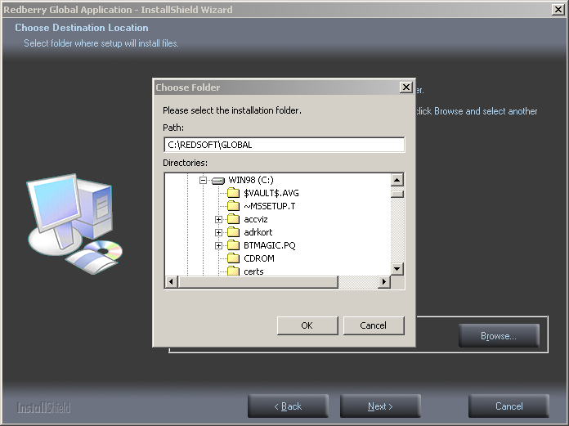 | If you want to install the Application in a Drive other than C:\ for example on a File Server  Press the Button  Remember when selecting a Destination other than C:\REDSOFT\GLOBAL try to keep the Folders in the location REDSOFT\GLOBAL so that other parts can also be installed in the REDSOFT\ Folder  Press the Button to continue with the installation
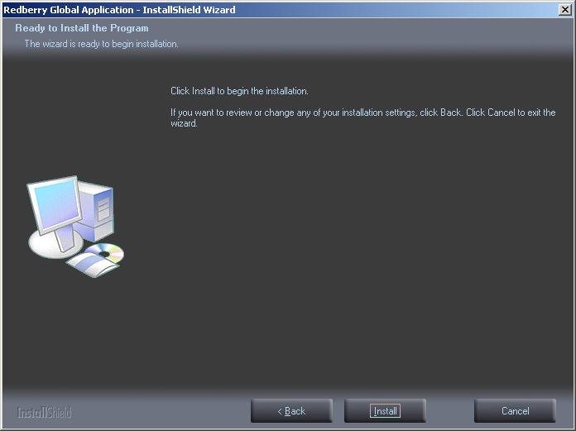 | You have now reached the point when the application is ready to actually be installed.  If you are happy to continue  Press the Button to Install
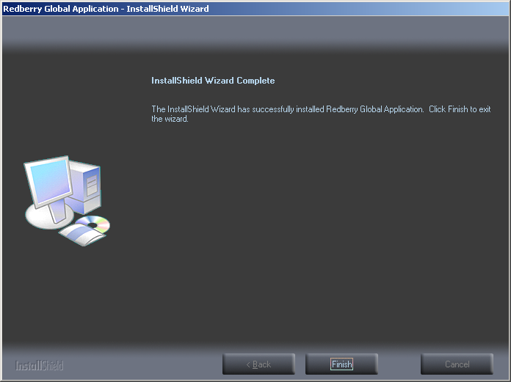 | Press the Button to Finish the Install

Setting Up Redberry Global Application

 | We now need to setup a working DATA folder, in the Global Application Folder  On the Computer Desktop you will find a Folder Icon Redberry Global Tools
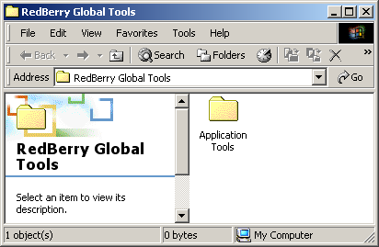 | If you open this folder inside you will find another Folder  Application Tools  Open this Folder
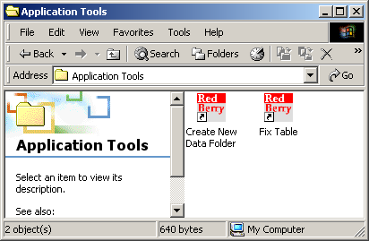 | Inside the Application Tools you will find Icons,  Double-Click on the Icon  Create New Data Folder
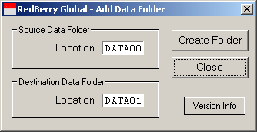 | The Dialog shown on the Left will appear, the Source Data Folder DATA00 was installed by the Setup. The Destination Data Folder is the DATA Folder we are going to create, you cannot change this.  Click on the Create Folder Button
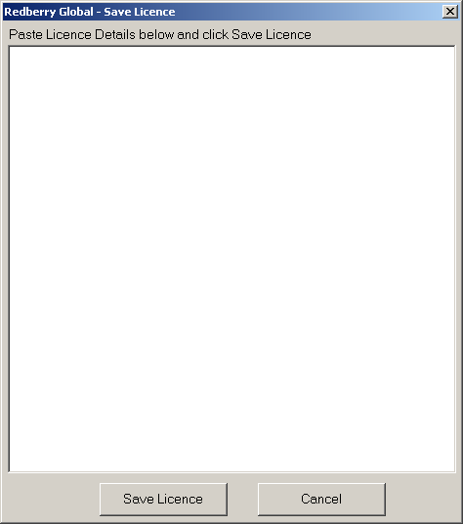 | The Next Dialog you will see appear is the Save Licence Dialog.  You should have been sent a Licence for the Customer. This Licence might have been sent to you in the Body of an Email. All you need to do is Cut the Licence from the Email and Paste into the Save Licence Window.  Please note though you should Cut the Licence to include the << and >> in your Cut
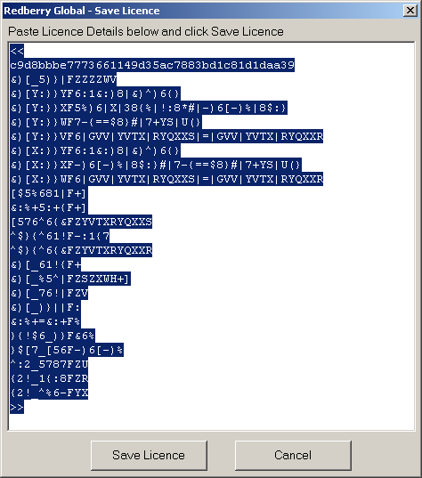 | Once you have Pasted the Licence into the Window  Click on Save Licence Button.  If you are setting up the Redberry Global Application for more than one Company, you will need to repeat the process to Create further DATA Folders, remember though you should have more than one Licence.

Redberry Global Update Manager

Installing Redberry Global Update Manager

Run Application Setup: global_update.exe

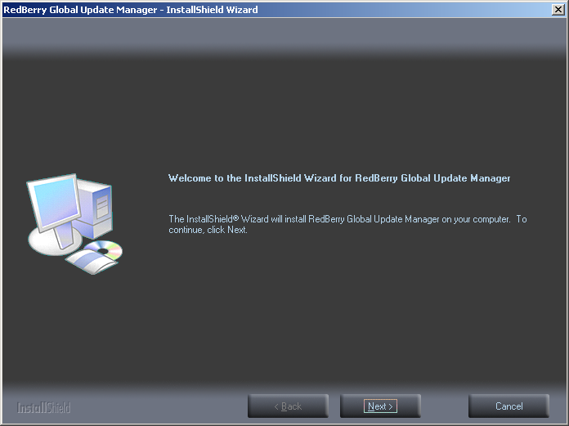 | Press the Button to continue with the installation
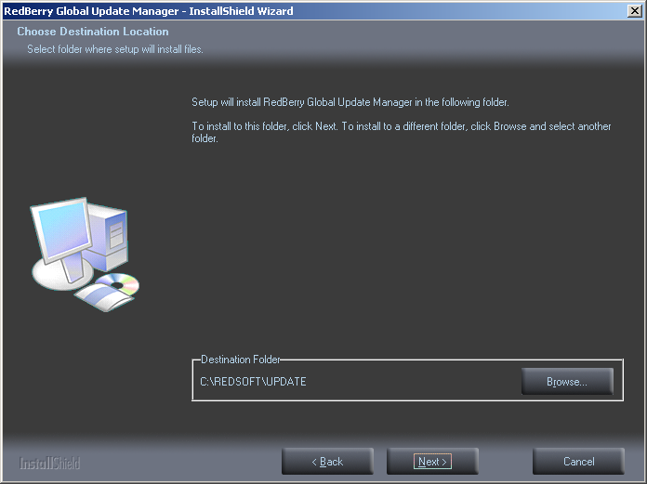 | Select Destination Folder for Installation  Default offered – C:\REDSOFT\UPDATE  If you installed the Redberry Global Application on the same P.C. but in a different location the Destination Folder will be obtained from the Application Install.  If the Destination Folder is not the same as the Application Install, see the next section, otherwise  Press the Button to continue with the installation.
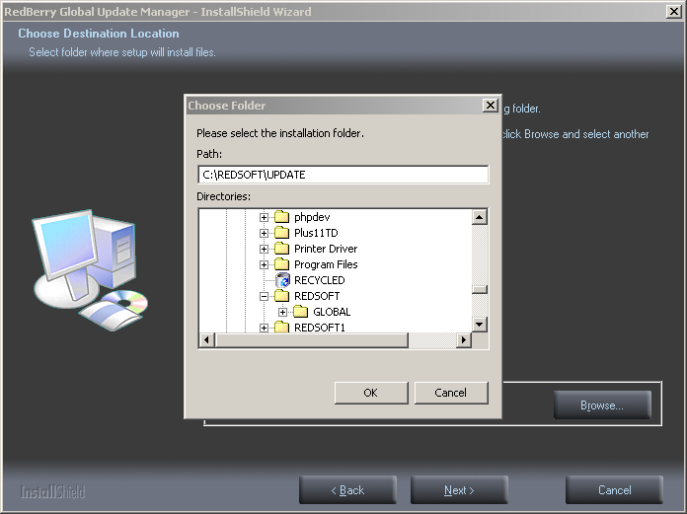 | If you have Pressed the Button above you can skip this section.  If you want to change the Destination Folder for the Install.  Press the Button.  Remember the Destination Folder must contain the Redberry Global Application.  Press the Button to continue with the installation
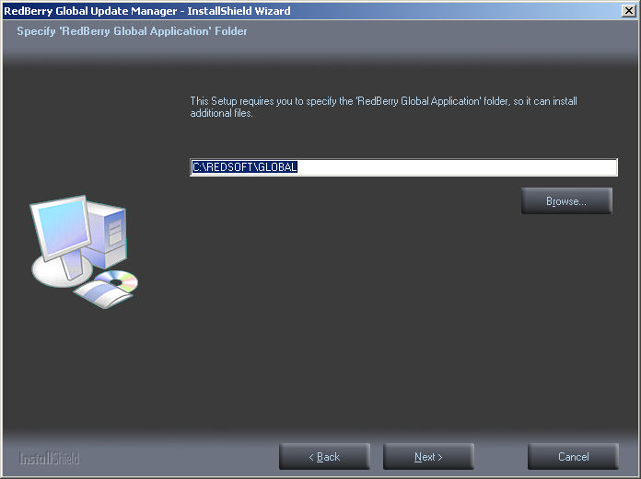 | Next you will be asked for the location of the Redberry Global Application, which you installed Earlier.  If you are installing the Update Manger on the same P.C. you installed the Application, then the Install will obtain the folder from the Application Install.  This Install expects to find the application file GLOBAL32.EXE in the Destination Folder if it does not it will refuse to install.  Press the Button to continue with the installation.
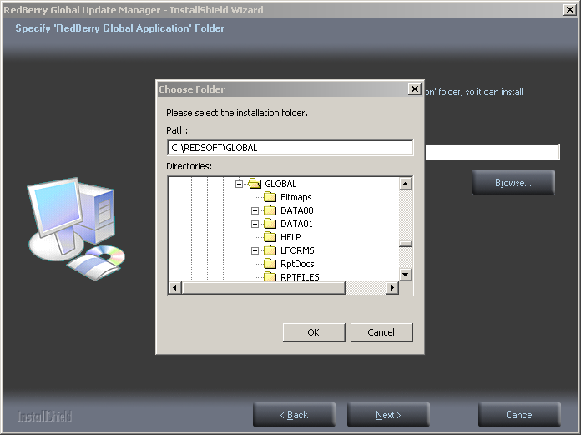 | If you have Pressed the Button above you can skip this section.  If you are not installing the Update Manager on the same P.C. as the application itself then you will need to locate the folder.  Press the Button.  Locate the Application Location.  Press the Button to continue with the installation
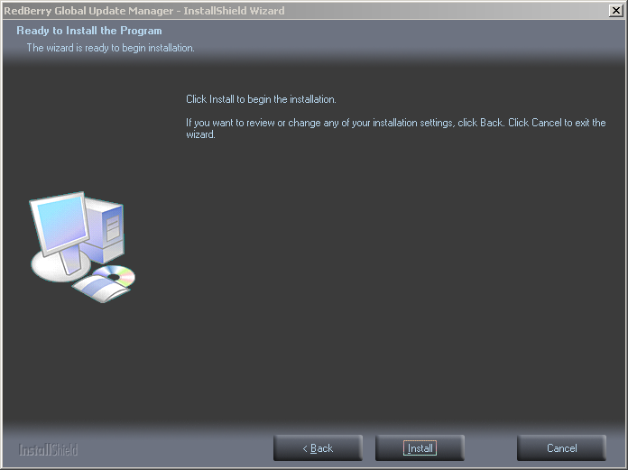 | You have now reached the point when the application is ready to actually be installed.  If you are happy to continue  Press the Button to Install
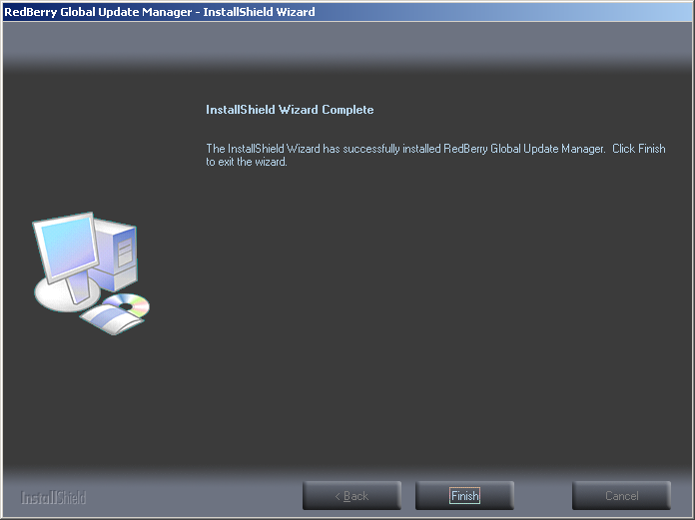 | Press the Button to Finish the Install

Setting Up Redberry Global Update Manager

Actually the Redberry Global Update Manager needs no further Setting Up, unless you want it to check for new updates overnight, or when you are not using the Application. Below shows how you can start the Application, and below that how you can configure it to check for updates.

We now need to setup the Email Manager.

On the Computer Desktop you will find a Folder Icon Redberry Global Tools
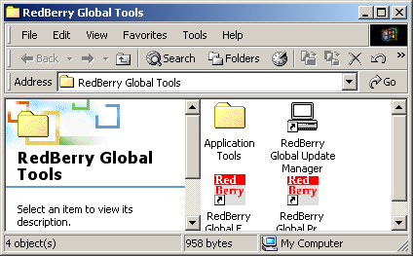 | Inside this folder you will find an Icon for the Redberry Global Update Manager  Double-Click this Icon

The Redberry Global Update Screen can be seen below, it is currently running in MANUAL mode which it will only check for updates, when you press the Check for Update Button. (See figure 1 below)

To change Redberry Global to Automatic Mode, press the Settings Button. Then Tick the Daily Check for Updates option and adjust the Start and Finish Time to a Time when Redberry Global would not normally be in use. (See figure 2 Below).

Redberry Global is now in Automatic Mode and will check for updates during the Times stated. Redberry Update actually only checks for Updates once in each 24 hour period, but if for some reason the Internet then it will continue to check until the stated Finish Time, after that it will wait until the next Start Time.

You can continue to check manually for Updates even when Redberry Update is in Automatic Update Mode by pressing the Check for Update Button.

One final note that Redberry Update will never check for New updates whilst the Application is in use, please ensure you never leave yourself logged into the Application when you leave the office.

Figure 1. Redberry Update in Manual Mode
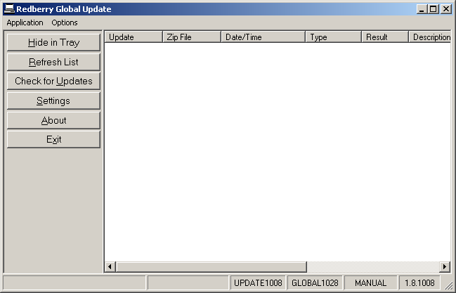
Figure 2 Setting up Redberry Update for Automatic Update
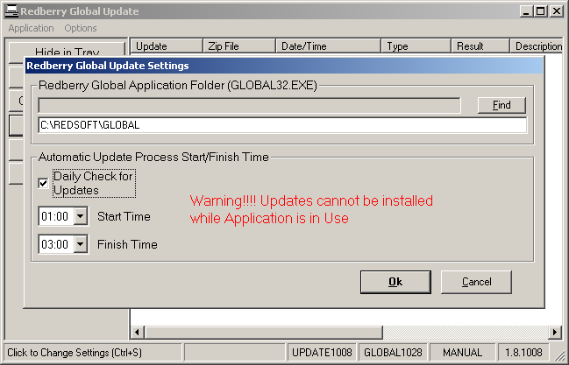

Figure 3 Redberry Update in Automatic Mode
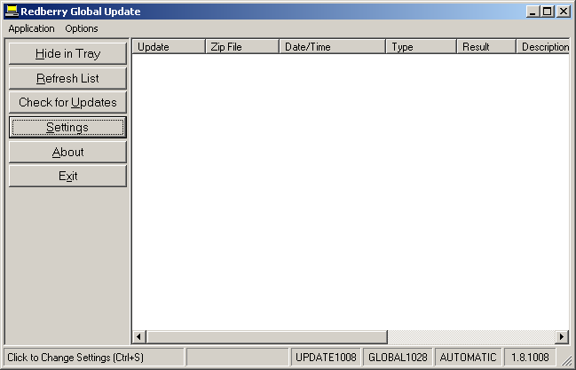

Redberry Global Print Manager

Installing Redberry Global Print Manager

Run Application Setup: global_spoolit.exe

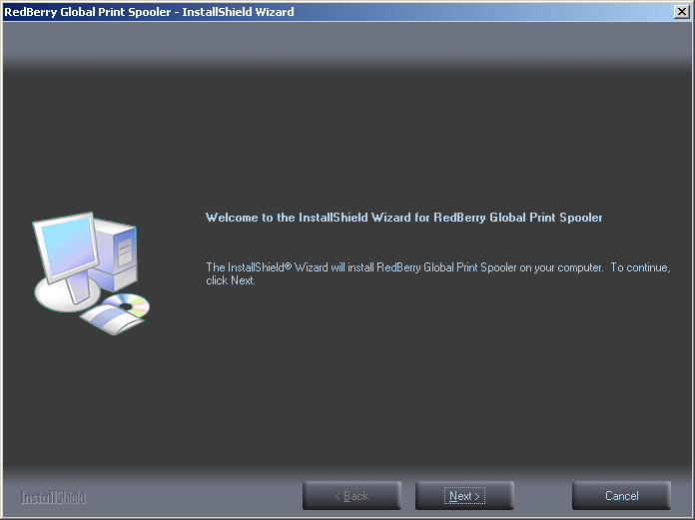 | Press the Button to continue with the installation
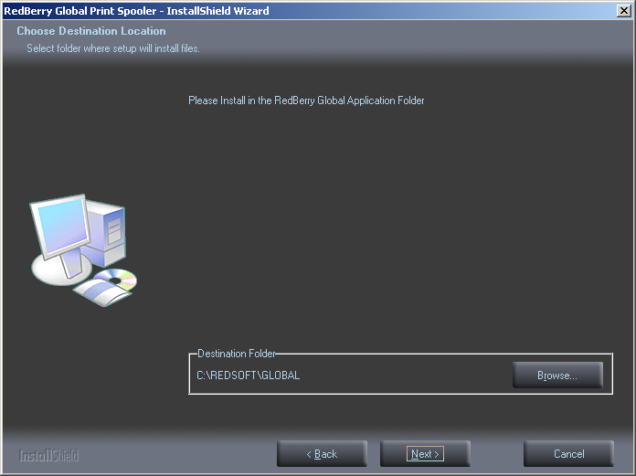 | Select Destination Folder for Installation  Default offered – C:\REDSOFT\GLOBAL  If you installed the Redberry Global Application on the same P.C. but in a different location the Destination Folder will be obtained from the Application Install.  If the Destination Folder is not the same as the Application Install, see the next section, otherwise  Press the Button to continue with the installation.
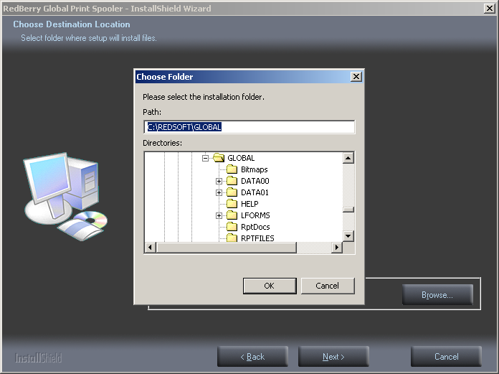 | If you have Pressed the Button above you can skip this section.  If you want to change the Destination Folder for the Install.  Press the Button.  Remember the Destination Folder must contain the Redberry Global Application.  Press the Button to continue with the installation
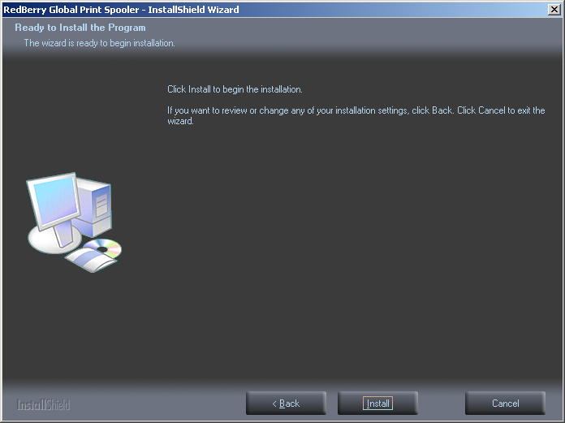 | You have now reached the point when the application is ready to actually be installed.  If you are happy to continue  Press the Button to Install
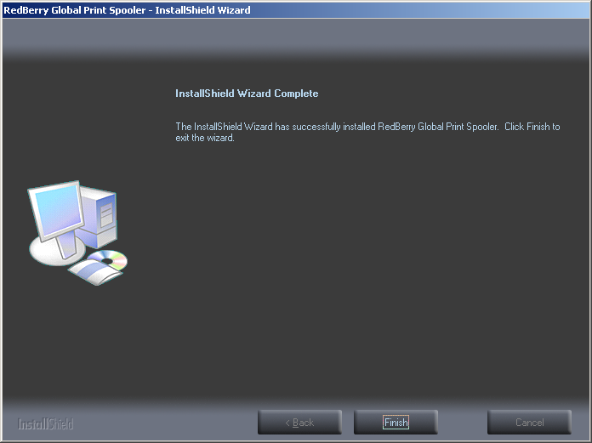 | Press the Button to Finish the Install

Setting up Redberry Global Print Manager

In order to complete the ‘Redberry Global Print Spooler’ Setting Up you now need to run the Application for the first time.

See the Redberry Global Print Manager Configuration for more details on the Setup.

We now need to setup the Print Manager.

On the Computer Desktop you will find a Folder Icon Redberry Global Tools
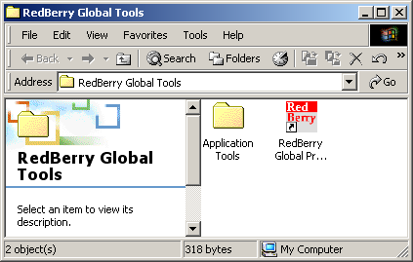 | Inside this folder you will find an Icon for the Redberry Global Print Spooler  Double-Click this Icon
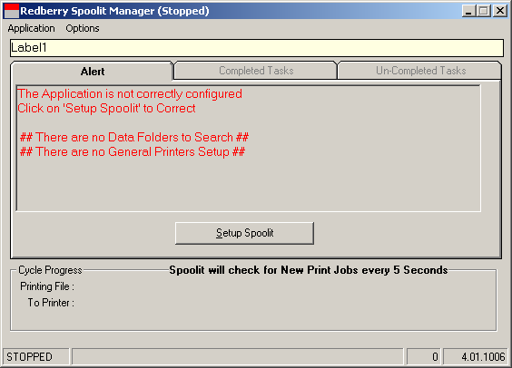 | Because you have only just installed this utility it now requires setting up. Click on the Setup Spoolit Button.
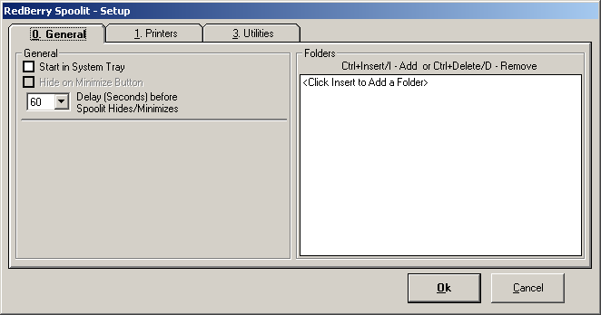 | On the first Tab ‘0 – General’ the most important part to setup is the Folders  Press Ctrl+Insert or Ctrl+I to Insert a DATA Print Folder. As we have installed the Application in C:\REDSOFT\GLOBAL and the created a User Data Folder DATA01 the Destination we are looking for is  C:\REDSOFT\GLOBAL\DATA01\SPOOL  As a rule only One Copy of the Print Manager ever needs to be installed if you created a second user Data Folder then Press Ctrl+Insert and point to  C:\REDSOFT\GLOBAL\DATA02\SPOOL
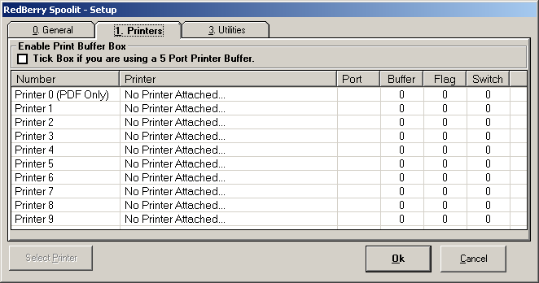 | On the Second Tab ‘1 – Printers’ we must at least Setup One Printer.  Select Printer 1 in the List and then Press the Select Printer Button and Select the Printer for this Printer.  The Printer you select can be attached to any Computer and Shared, but you must have Installed the Printer Driver on this P.C. in order to use this Printer.  If you are using a number of DOT-MATRIX Printers, Redberry Global only needs these to use a Generic Text Driver. Redberry Global does not actually use the Windows Printer Driver to layout its Document it puts the completed Document in the Printer Queue
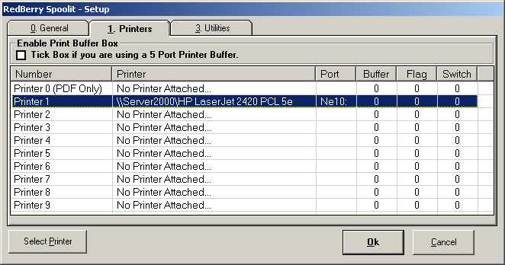 | When you have selected your first Printer you can Press the OK Button.
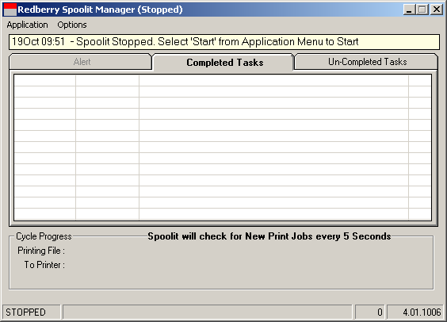 | The Print Manager is now configured to its Basic Setup.  As you do not need it at present you can Exit.  Please Note: Redberry Global Print Manger should always be running when you are using Redberry Global otherwise you will not get any Printouts.  You may decide to use more than One Printer for your Documents in which case you change the Setup by select Setup in the Application Menu.

Redberry Global Email Manager

Installing Redberry Global Email Manager

Run Application Setup: global_dial.exe

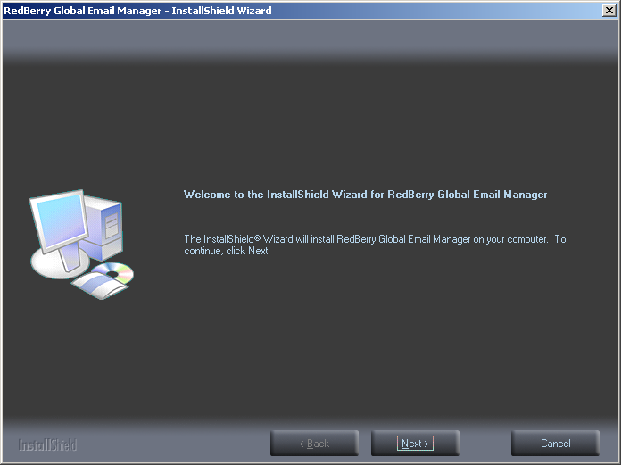 | Press the Button to continue with the installation
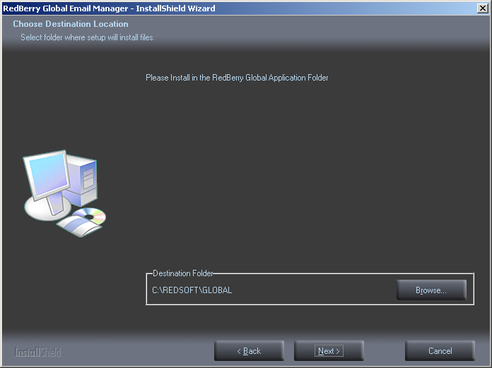 | Select Destination Folder for Installation  Default offered – C:\REDSOFT\GLOBAL  If you installed the Redberry Global Application on the same P.C. but in a different location the Destination Folder will be obtained from the Application Install.  If the Destination Folder is not the same as the Application Install, see the next section, otherwise  Press the Button to continue with the installation.
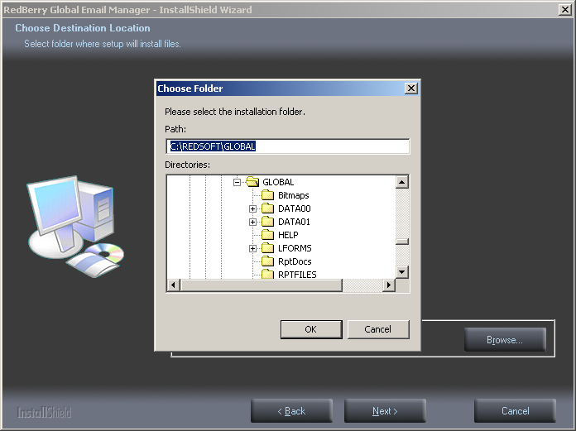 | If you have Pressed the Button above you can skip this section.  If you want to change the Destination Folder for the Install.  Press the Button.  Remember the Destination Folder must contain the Redberry Global Application.  Press the Button to continue with the installation
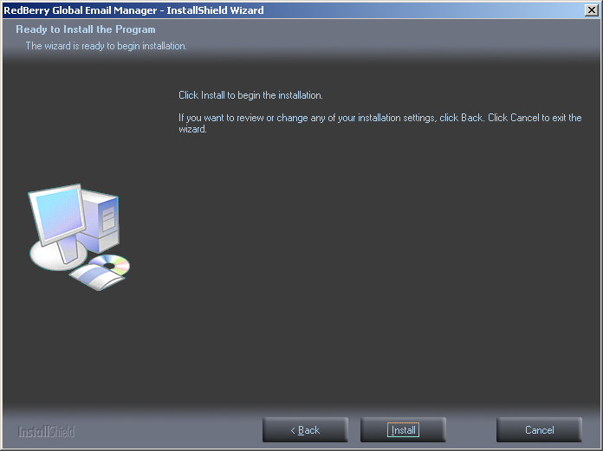 | You have now reached the point when the application is ready to actually be installed.  If you are happy to continue  Press the Button to Install
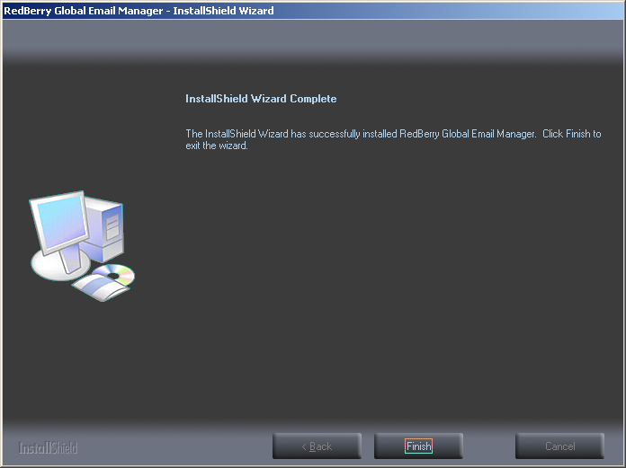 | Press the Button to Finish the Install

Setting Up Redberry Global Email Manager

We now need to setup the Email Manager.

On the Computer Desktop you will find a Folder Icon Redberry Global Tools
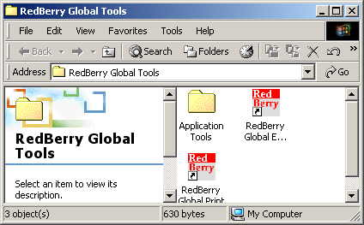 | Inside this folder you will find an Icon for the Redberry Global Email Manager  Double-Click this Icon
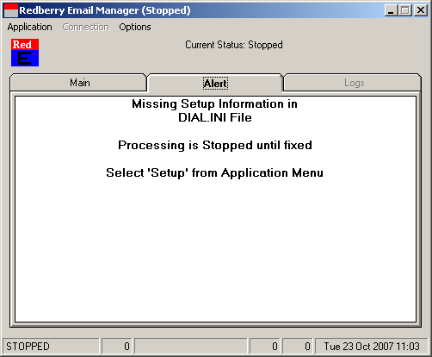 | Because you have only just installed this utility it now requires setting up.  Select Setup from Dropdown Application Menu.
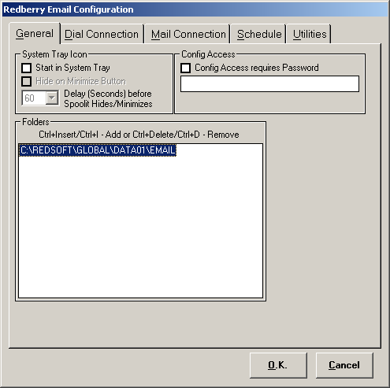 | Tab: General  The most important part to setup is the Folders,  Press Ctrl+Insert or Ctrl+I to Insert a DATA Email Folder. As we have installed the Application in C:\REDSOFT\GLOBAL and the created a User Data Folder DATA01 the Destination we are looking for is  C:\REDSOFT\GLOBAL\DATA01\EMAIL  As a rule only One Copy of the Email Manager ever needs to be installed if you created a second user Data Folder then Press Ctrl+Insert and point to  C:\REDSOFT\GLOBAL\DATA02\EMAIL
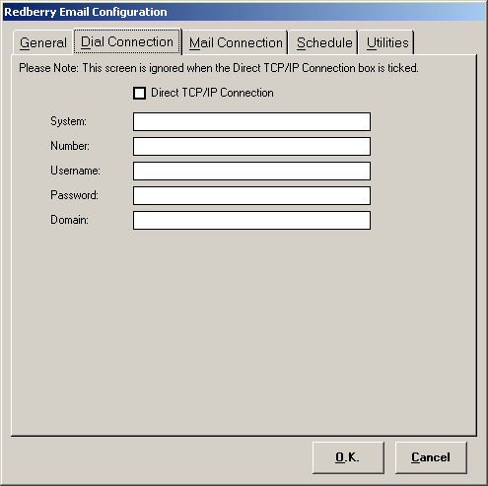 | Tab: Dial Connection  If you connect to the Internet using Broadband you are not required to complete this screen, but you must tick the Direct TCP/IP Connection option.  If you connect to the Internet using Dialup then you need to add the Dialup Instructions, such as Phone Number, Username and Password. In this case you must not tick the Direct TCP/IP Connection option.
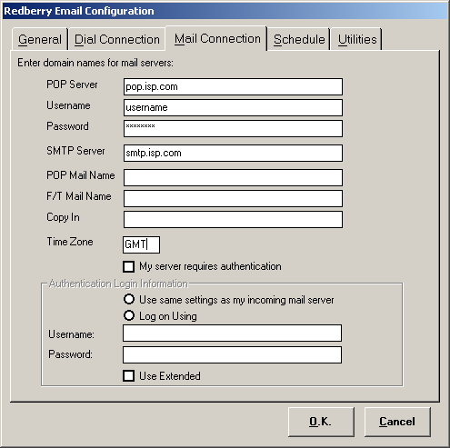 | Tab: Mail Connection  You need to fill in your details from your ISP for your POP Server and SMTP Server
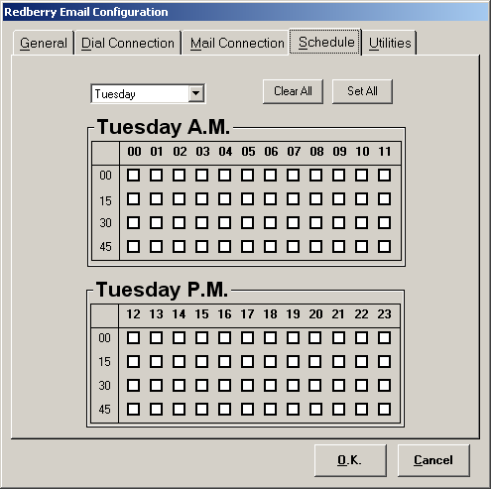 | Tab: Schedule  This tab allows you setup a Schedule when you want the Email Manager to Connect to the Internet to Send Outgoing Emails.  If you connected by broadband then there is no reason to setup a schedule because you are connected all the time, so Emails can be sent as they arrive in Email Folder.  If you connected by Dialup then each connection is going to cost you the price of connection so you might want to schedule the sending of Emails.
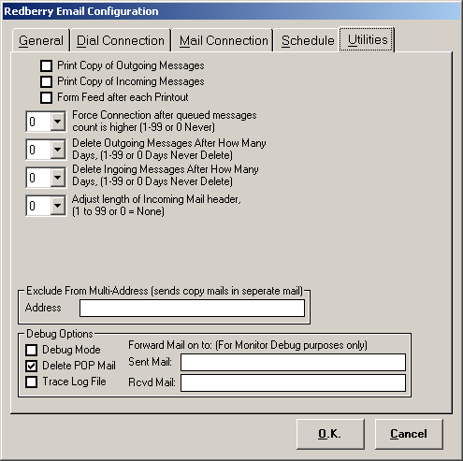 | Tab: Utilities  This Tab contains options additional options, which you may wish to use in certain situation.
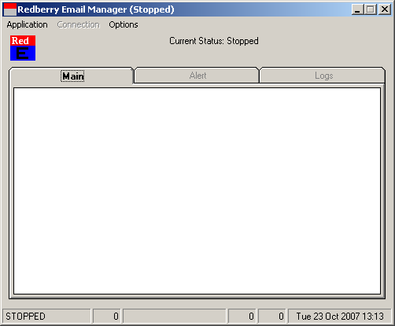 | To complete the Setup and Save the Settings press the OK Button.  If you have completed the minimum setup then the Alert screen will clear which means the Email Manager is ready to start.  As you do not need it at present you can Exit.  Please Note: Redberry Global Email Manger should always be running when you are using Redberry Global otherwise you will not send any Emails.

Redberry Global Client

Installing Redberry Global Client

Run Application Setup: global_client.exe

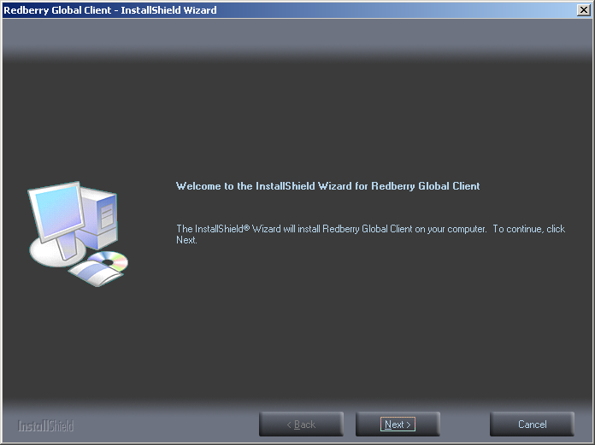 | Press the Button to continue with the installation
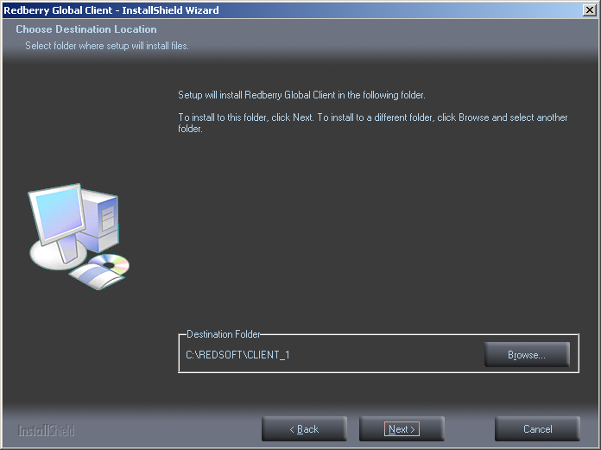 | Select Destination Folder for Installation  Default offered – C:\REDSOFT\CLIENT_1  The Redberry Global Client Install is a multi-install application, which means that you can run it more than once.  You will need to run the Installation for each DATA Folder you have created in the Application Folder, each separate installs should be in separate Folders  C:\REDSOFT\CLIENT_1  C:\REDSOFT\CLIENT_2  Press the Button to continue with the installation.
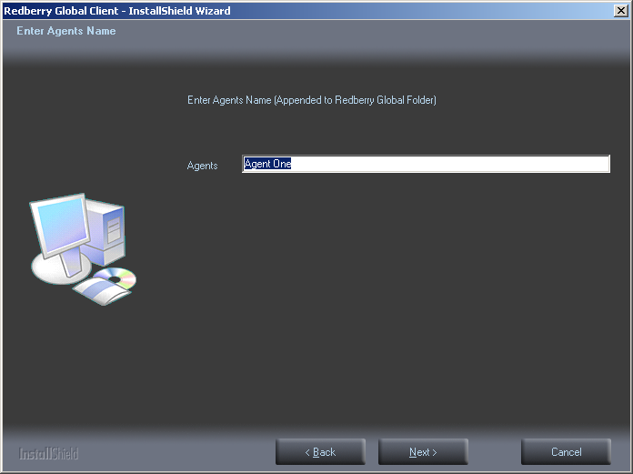 | With each installation you are able to add the Agents name to shortcut, so that the user knows which Agent he is going into.  Press the Button to continue with the installation.
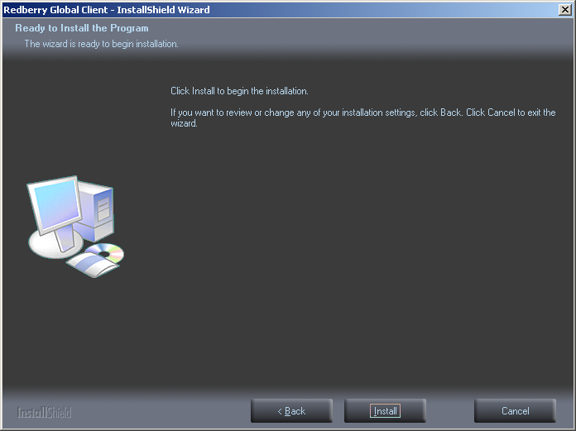 | You have now reached the point when the application is ready to actually be installed.  If you are happy to continue  Press the Button to Install
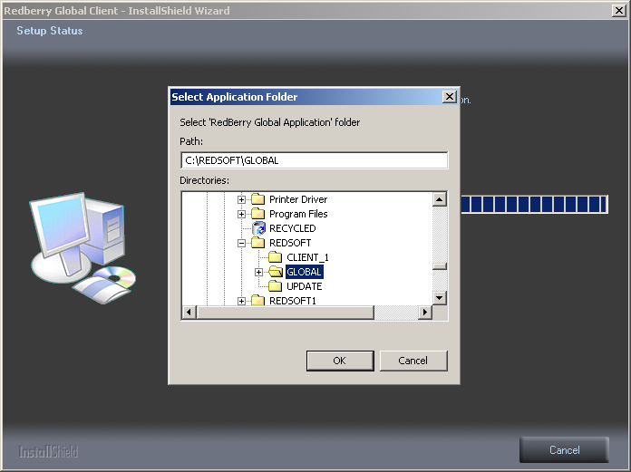 | After the Client has installed you will be asked to point to the Redberry Global Application Folder.
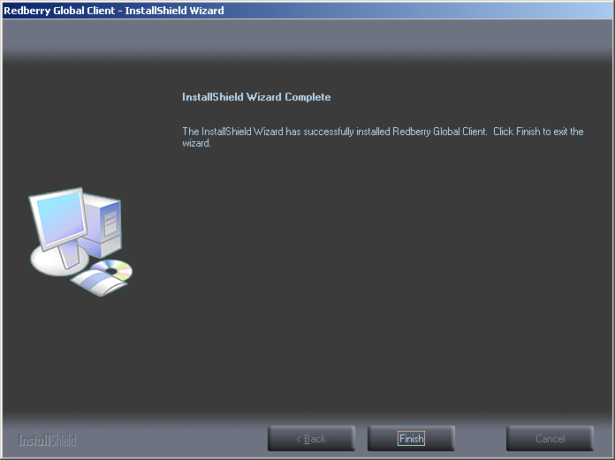 | Press the Button to Finish the Install

Setting Up Redberry Global Client

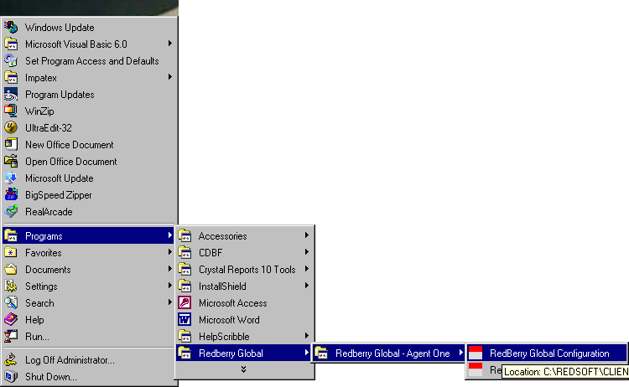
Start Programs Redberry Global Redberry Global – Agent One
Redberry Global Configuration

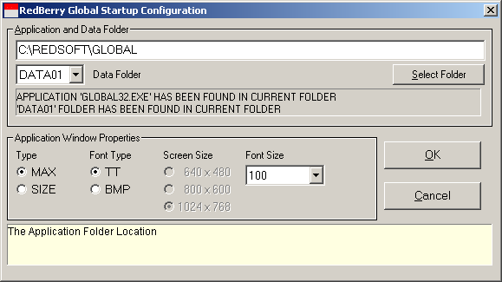

The above default Setup was installed when the Client was installed and this should sufficient to start the Application.

Starting Redberry Global Client

Start Programs Redberry Global Redberry Global – Agent One
Redberry Global Processing
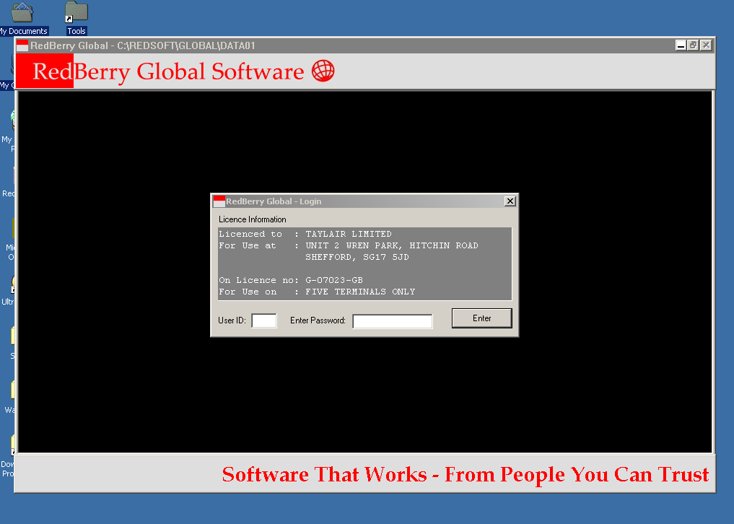
When you start you start the Application the Screen should look something like the above, if for reason the application screen size is not to your choice you can adjust it by reducing the font size in the configuration.

Redberry Global Reports

Installing Redberry Global Reports

Run Application Setup: global_reports.exe

