Background to Redberry Global Print Manager

The Redberry Global Print Manager was designed to centralise the Printing function from Redberry Global from one P.C.

In the past Redberry Global printed its documents from the actual application on each workstation, with the introduction of network printers this meant we had to install print drivers on each workstations for the printers and then attach to the actual P.C. hosting the Printer, in many cases we were installing printers which were only going to be used by Redberry Global, for example a Printer for House Waybills or Master Waybills.

Now with Redberry Global Print Manager we only need to install the Print Driver on at most 2 P.C., the P.C. were the Printer is attached and the P.C. were we installed the Print Manager.

The Redberry Global Application still builds the document but then puts the document into file on the disk and the Print Manager sends the file to the Printer.

This Document gives you full details on how we configure Redberry Global Print Manager on the following pages.

Tab 0, General

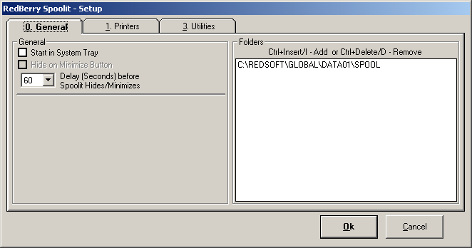

Start in System Tray

If Ticked Redberry Global Print Manager puts itself in the System Tray after a Delay Period of stated seconds

If Unticked then Print Manager minimizes itself after the Delay period stated.

Hide on Minimize Button

Print Manager would normally return to the System Tray when the User presses the Close Button. By Ticking this option though Print Manager will return to the System Tray, and the Close Button will Close the program.

Delay (Seconds) before Spoolit Hides/Minimize

When the Print Manager is running it automatically return to the System Tray or mnimize itself after the stated seconds, even when its left open by the User.

Folders (This has already been breifly covered in the Installation Guide.)

Redberry Global needs to know where to look for the files it needs to print. Normally you only need to have one copy of Print Manager running regardless of the number of DATA folders you have created for the Licenced Users

To add new DATA Folders you press Ctrl+Insert or Ctrl+I. DATA Folders are always found in the Redberry Global Application Folder, and the print File Folder SPOOL is found in the DATA Folder. So if we had just created a second DATA Folder for a second User on the same site, we would press Ctrl+Insert and this time point to C:\REDSOFT\GLOBAL\DATA02\SPOOL.

To remove a Folder from the list we simply Highlight the Folder and press Ctrl+Delete or Ctrl+D.

Tab 1. Printers

We select a Printer by Highlighting the printer we want to configure. Then we press the Select Printer Button.

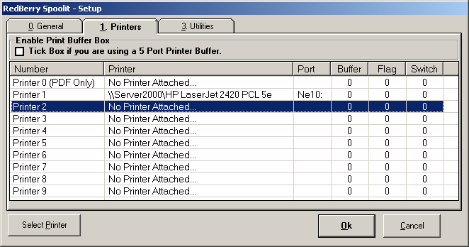

In this example we are going to attach a printer to printer 2

We first select the Printer from the Drop down list of Printers we have available from this P.C.

T-Switch – This option allows the User to use a simple T-switch to switch between Printers on this P.C. This function only works though if you are installing the Print Manager on the P.C. you have the Printers connected and of course it will interrupt the User when it needs them to switch Printers. Please also note that if Printer 1 and 2 are on a T-Switch then both printers should be ticked.

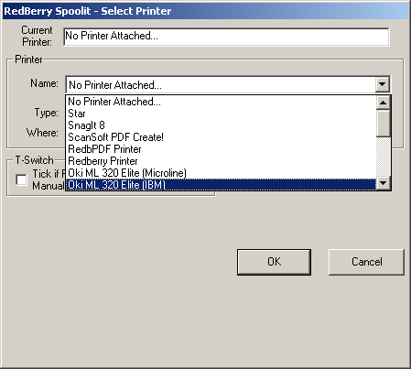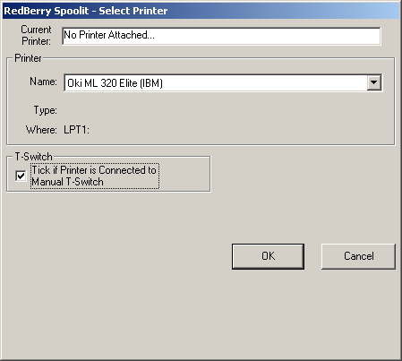

Tab 3. Utilities

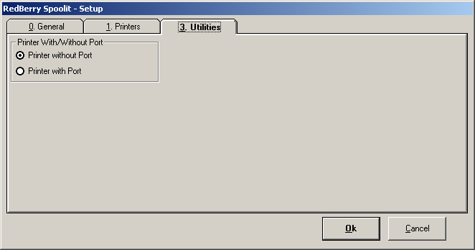

Printer With/Without Port

In the section above you will note that Printer 1 is on port Ne10:. This is actually a Network Virtual Port which actually does not exist, these ports can change if the P.C. hosting the printer is re-started. The print manager used to send the prints to the printer name on the printer port to ensure that it went to the right printer, however with the introduction of virtual ports this meant when the virtual port changed the Print Manager could no longer find the printer. We now normally only look for the printer name and send the documents to that printer, as a rule no 2 printers can have the same name on the same P.C. so this is not a real problem.

